LCD MONITOR

User manual

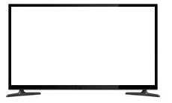

Table of contents

Important safety information 2
In The Box 4
Connections 4
Rear interface 4

Control Layout 5

How to connect your monitor 5
On-Screen Display (OSD) Operation 7
AV Input Configuration 7
HDMI Input Configuration 9
VGA Input Configuration 12

Manufacturer reserves the right to upgrade the product without notice!

1.

IMPORTANT SAFETY INFORMATION

ENVIRONMENT

- Do not install the monitor outdoors or in any hostile environment. To prevent fire or electric shock, do not expose monitor to rain or moisture. Avoid placing the monitor in areas subject to extreme temperature such as direct sunlight or near a heating appliances/equipment (such as amplifiers, etc) as this may result in overheating and damage.
- This monitor is designed to be used in the office or home. Do not subject it to vibrations, dust or corrosive gases.
- To obtain a clear picture, do not expose screen to direct illumination or sunlight. Using the monitor against a bright background and where sunlight or other light sources shine directly on to the monitor can increase eye fatigue

POWER CORD

- Neither the monitor itself nor any other heavy object should rest on the power cord.
- Protect the power cord from being walked on or pinched particularly at plugs, convenience receptacles and the point where they exit from the monitor.
- Firmly grasp the plug when disconnecting the power cord. Do not pull the power cord itself.
- Do not modify or damage the cord. Damage to a power cord can cause fire or electric shock.
- This monitor is designed to operate on 100-240V AC supply. Take caution in connecting it to the correct supply using the correct power cord.

MOUNTING

- Always place the monitor on a secure table or have it properly mounted to the wall. Do not hang anything on the monitor.
- Ensure the monitor is located close to a power outlet that is easily accessible, as removing the power cord is the only way to isolate power
2.

USING A WALL MOUNT

Caution: Any wall mount must bear a minimum of 5x the monitor’s net weight to mount safely. The stand must be removed first before mounting this way.
- Place the monitor face down on a surface that is soft, yet strong enough to hold the monitor.
- Use a screwdriver to remove the screws from the four holes on each side of the bottom of the monitor’s base.
- Make sure all cables are already connected to the monitor.
- Follow the directions included with the wall mount to fix the monitor to the wall.

STORAGE

- Unplug the monitor if it will not be used for a long period.

VENTILATION

- Never cover or block the ventilation slots in the monitor. A minimum distance of at least 10 cm should be maintained around the unit for sufficient ventilation.
- Never insert any foreign object, metal or liquid into the ventilation slots, as this could result in fire or electric shock.
- Avoid installing a DVR or other equipment too close to the monitor. Keep such equipment at least 30 cm away from the monitor.

WATER AND MOISTURE

- The monitor should not be exposed to any moisture or liquid.
- Do not use the monitor near water.
- Do not touch the monitor or cable with wet hands as this may cause electric shock or damage.

CLEANING

- Unplug the unit from the wall outlet before cleaning.
- Do not use liquid or aerosol cleaners. Use a dry soft lint-free cloth for cleaning. If dust is persistent, wipe with a slightly damp cloth.
3.

IN THE BOX

1 x LCD Monitor, 1 x AC adapter, 1 x HDMI cable, 1 x User Manual

CONNECTIONS

Rear Interface

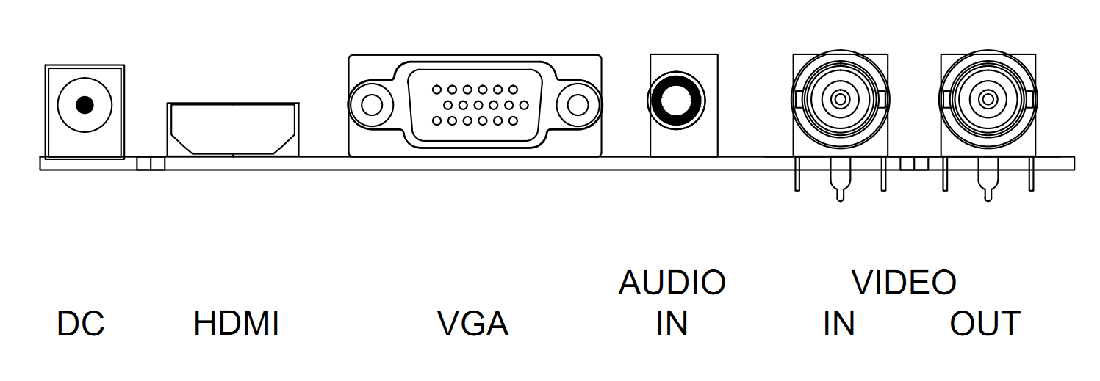

DC: Only use the 12v DC power supply included with the monitor.

HDMI: (High-Definition Multimedia Interface) Supports digital video and audio connections.

VGA: 15 pin D-sub cable for standard VGA connection.

Audio IN:
3.5 mm stereo jack connection for audio input when using VGA /AV connector.

VIDEO/AV IN:
BNC connections supporting composite video inputs from equipment such as Cameras or DVR’s.

VIDEO/AV OUT:
Composite video loop though output – connect a second monitor.

4.

CONTROL LAYOUT

The control buttons are located on the right hand rear side of the monitor.
5keys series

SOURCE - + MENU POWER

7keys series

SOURCE - + ∨ ∧ MENU POWER

SOURCE: Selects input mode – AV,HDMI , VGA.

MENU: Access to the On Screen Display (OSD) menu.

＋ and －: Volume controls up/down, confirm input source selection and navigation in the OSD.
POWER: Turns the monitor on or off.

HOW TO CONNECT YOUR MONITOR

- Connecting using AV - Composite Video

Connect your video cable with BNC connector to the AV connector on the rear of the monitor, and the other end to your DVR/Camera etc.
5.

If audio input is required, connect the 3.5 mm stereo audio cable to the AUDIO INPUT on the rear of the monitor and to the Audio Output connector on the DVR/Camera etc.
Connect power to the monitor and video source, and switch on. Using the SOURCE button, press repeatedly until either ‘AV’ (depending on the connection used) is highlighted on the display at the top of the monitor's screen, and press ‘+’ to select.

- Connecting using HDMI

Connect one end of a HDMI cable (optional) to the HDMI connector on the rear of the monitor, and the other to the HDMI out connector on the PC/DVR. This connection will support both video and audio transmission.
Connect power to the monitor and video source, and switch on. Using the SOURCE button, press repeatedly until ‘HDMI’ is highlighted on the display at the top of the monitor's screen, and press ‘+’ to select.

Connecting using VGA

Connect one end of a 15-pin monitor cable to the VGA connector on the monitor and the other end to the PC/DVR. Note - if your PC/DVR connector isn't 15-pin D-sub you may need an adapter to connect with this cable.

If audio is required, connect one end of the 3.5 mm stereo audio cable (sometimes referred to as 1/8" stereo jack) to the PC Audio IN connector on the back of the monitor and the other end to the audio output on the PC/DVR.

Connect power to the monitor and video source, and switch on. Using the SOURCE button, press repeatedly until ‘VGA’ is highlighted on the display at the top of the monitor's screen, and press ‘+’ to select.

Ensure all cable connections are secure - tighten all cable screws. Movement and vibration may dislodge cables that are improperly connected. Route all wiring and cabling away from any heat sources and sharp metal edges to avoid damage.

6.

BASIC ON-SCREEN DISPLAY SETUP

- To access the OSD Menu press ‘MENU’.

- Use the ‘＋’ or ‘－’ buttons to select the required menu item, then press the ‘SOURCE’ button to select the Sub menu.

- Continue to use the ‘SOURCE’ button to highlight the required field, then press ‘＋’ or ‘－’ to adjust the setting.

- Press the ‘MENU’ button to return to previous menu.

- Press the ‘MENU’ button again to exit the OSD Menu completely.

- N.B. To Lock or Unlock OSD settings after set up.
Press and hold "menu" button for 5 seconds.

The layout of the OSD will change depending on the input that is selected.

AV - Input Configuration

- Picture

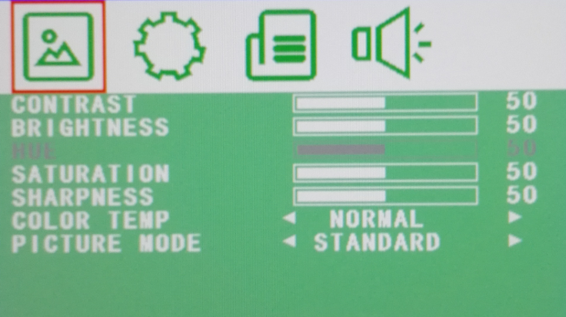

CONTRAST: (0–100) Set the difference between the light and dark areas of the picture.
BRIGHTNESS: (0–100) Set how bright the display is.
HUE: -50 to +50 (only available if NTSC)
SATURATION: (0-100)
7.

SHARPNESS: (0-100)
COLOR TEMP: Select the color temperature. (Normal/Warm/Cool)
PICTURE MODE: Select defaults or save user setting. ( User/Standard/Soft/Vivid)

- OSD
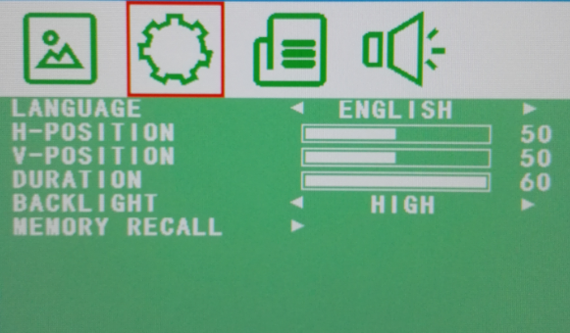

LANGUAGE: Select preferred language for OSD. (En/Ch/Ger/Fr/Sp/It/Pt/Pl/Ru)
H-POSITION: (0-100) Set the horizontal position of the OSD.
V-POSITION: (0-100) Set the vertical position of the OSD.
DURATION: (5-60) Set seconds for the OSD to automatically close.
BACKLIGHT: Set power level in use by backlight (HIGH/MID/LOW)
MEM-RECALL: Restore all factory defaults.

- Function
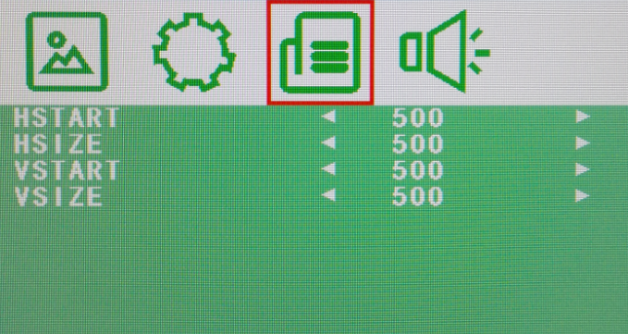

HSTART: Set left alignment point of image.
HSIZE: Set horizontal size of image.
VSTART: Set lower alignment point of image.
VSIZE: Set vertical size of image.
8.

- Audio
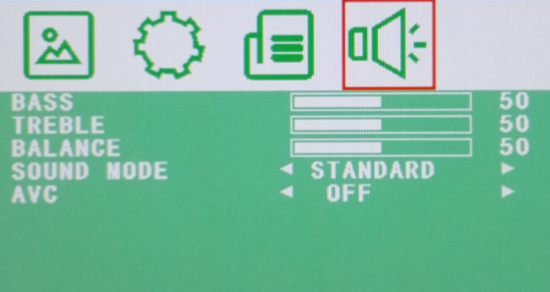

BASS: (0-100)
TREBLE: (0-100)
BALANCE: (-50 to +50)
SOUND MODE: Set user or preset audio configurations.
(User/Standard/Movie/Music)
AVC: (ON/OFF) Automatic Volume Control

HDMI - Input Configuration

- Picture

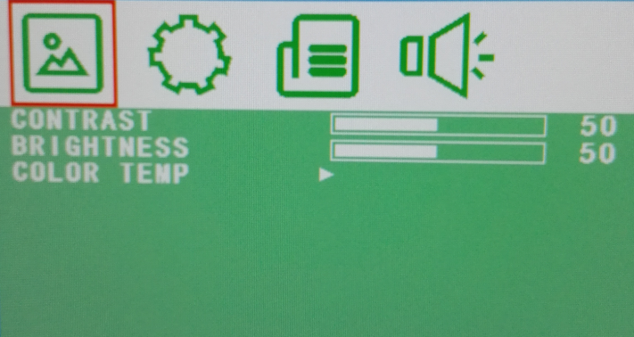

CONTRAST: (0–100) Set the difference between the light and dark areas of the picture.
BRIGHTNESS: (0–100) Set how bright the display is.
9.

COLOR TEMP: Select the color temperature Menu.

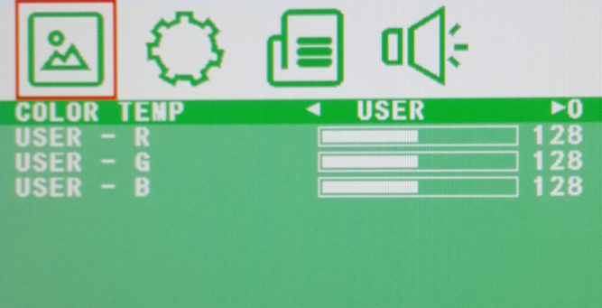

COLOR TEMP: Select color temperature preset.
USER - R: Set RED color level.
USER - G: Set GREEN color level.
USER - B: Set BLUE color level.

- OSD

LANGUAGE: Select preferred language for OSD. (En/Ch/Ger/Fr/Sp/It/Pt/Pl/Ru)
H-POSITION: (0-100) Set the horizontal position of the OSD.
V-POSITION: (0-100) Set the vertical position of the OSD.
DURATION: (5-60) Set seconds for the OSD to automatically close.
BACKLIGHT: Set power level in use by backlight (HIGH/MID/LOW)
MEM-RECALL: Restore all factory defaults.

10.

- Function

HSTART: Set left alignment point of image.
HSIZE: Set horizontal size of image.
VSTART: Set lower alignment point of image.
VSIZE: Set vertical size of image.

- Audio
BASS: (0-100)
TREBLE: (0-100)
BALANCE: (-50 to +50)
SOUND MODE: Set user or preset audio configurations.
(User/Standard/Movie/Music)
AVC: (ON/OFF) Automatic Volume Control

11.

VGA - Input Configuration

- Picture

CONTRAST: (0–100) Set the difference between the light and dark areas of the picture.
BRIGHTNESS: (0–100) Set how bright the display is.
COLOR TEMP: Select the color temperature Menu.

COLOR TEMP: Select color temperature preset.
USER - R: Set RED color level.
USER - G: Set GREEN color level.
USER - B: Set BLUE color level.

12.

- OSD

LANGUAGE: Select preferred language for OSD. (En/Ch/Ger/Fr/Sp/It/Pt/Pl/Ru)
H-POSITION: (0-100) Set the horizontal position of the OSD.
V-POSITION: (0-100) Set the vertical position of the OSD.
DURATION: (5-60) Set seconds for the OSD to automatically close.
BACKLIGHT: Set power level in use by backlight (HIGH/MID/LOW)
MEM-RECALL: Restore all factory defaults.

- Geometry

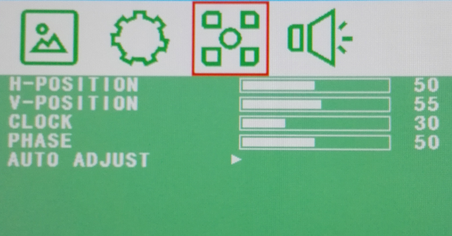

H-POSITION: Set horizontal image position.
V-POSITION: Set vertical image position.
CLOCK: Manually adjust clock synchronisation.
(If the clock setting of your image is not fine-tuned, you may observe periodic vertical bars of video noise on your image. These bars of noise are usually adjusted out when an Auto Configuration is performed. If the bars of noise are still present, this setting can be used to remove them.
13.

PHASE: If the phase of your monitor is not fine-tuned, you may observe the image being unstable in the horizontal axis. Use this option to manually correct.
AUTO ADJUST: Perform an automatic configuration of the Phase, Clock, vertical and horizontal position.

- Audio

BASS: (0-100)
TREBLE: (0-100)
BALANCE: (-50 to +50)
SOUND MODE: Set user or preset audio configurations.
(User/Standard/Movie/Music)
AVC: (ON/OFF) Automatic Volume Control

END

14.

